H.B. moves to fine adults who host underage drinkers
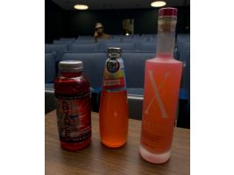
SLIDE SHOW:
H.B. moves to fine adults who host underage drinkers
3 Photos »
By JAIMEE LYNN FLETCHER / ORANGE COUNTY REGISTER
HUNTINGTON BEACH – Parents in the city now will be held financially responsible if they are caught serving alcohol to minors at parties.
A social-hosting ordinance, assessing a minimum $250 fine for violators, passed 5-2 at the City Council meeting on Tuesday with council members Matthew Harper and Jill Hardy dissenting.
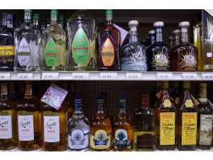
Parents in Huntington Beach could face a fine if caught allowing alcohol to be served to minors at home. The city is the fourth in Orange County to adopt a social-hosting ordinance.
SETH PERLMAN, AP
MORE PHOTOS »
ADVERTISEMENT
Huntington Beach will be the fourth Orange County city to adopt such an ordinance following Mission Viejo, Laguna Beach and Laguna Hills.
"This is one of those that is really easy to vote in favor of and it looks real good," Hardy said. "To stand up and oppose it is very brave, I think. I'm going to get accused of not listening to the parents ... or not thinking of the children... but it's just too easy for me to come up with how it goes bad."
Councilman Joe Carchio, who brought the item to the council, said teens and parents are "begging for this".
"Alcohol is the leading (substance) that creates problems that lead to drugs and so forth," he said. "These people came from the PTA and expressed their concern and wanted this because they need to have it in place because this is where the kids start."
The social-hosting ordinance will be added to the city's "loud parties" ordinance, which allows Huntington Beach to collect a fee for having the police respond to gatherings that are the subject of noise complaints.
The city can currently enforce the state's "contributing to delinquency" law, which covers any action by an adult that condones illegal behavior by a minor, including serving a teenager alcohol. A parent that breaks this law can be charged with a misdemeanor.
Setting up a rule that imposes a fine if a parent is caught serving minors alcohol gives officers an added tool to deter underage drinking, officials said.
Police can either charge a flat $250 fee for the violation or they can assess an itemized fee that could include things such as salaries of the officers during time spent responding to parties, the cost of equipment and the cost of any medical treatment if a police officer is injured, the ordinance says.
"This speaks in plain language about the nature of the problem, and it gives the police officer tools that we don't have now," said police Chief Kenneth Small. "This adds a civil citation process ... which is a much easier and simpler way for the police department to address it."
Hardy said she was concerned that parents could be wrongfully accused of hosting a party.
As a teacher, she said she hears how students go out of their way to hide things from their parents. She gave the example of teens watching movies in a home while the parents are upstairs and one teen sneaking in alcohol without the adults knowing.
"What if one kid gets sick and then they call their parents ... and that parent flips out and calls the police?" Hardy said. "The potential for a parent being accused of hosting when they aren't just seems too strong here."
The law will have some exemptions, including allowing alcohol for religious activities and allowing police to skip a citation if it is determined the host of the party took "reasonable steps to prevent underage drinking," the law says.
The ordinance will come back for a second reading at a future meeting before going into effect.
Contact the writer: 714-796-7953 or jfletcher@ocregister.com

